DIRECT DEPOSIT BANKING INFORMATION CHANGE |  |  |  |  |  | Contact Name:
Originator:
Faculty & Department
 |  |  |  |  |  | Contact Telephone:
 |  |  |  |  |  | Contact Email:
-- PLEASE PRINT --
PERSONAL DATA
Employee ID#: |  | Surname: |  |  |  |  |  |  | Given Name: |  |  |  |  | Prefix:
Pay Frequency: |  |  |  | Monthly: |  |  |  | Biweekly:

PREVIOUS BANK INFORMATION
Name of Bank:

Address of Bank: (street name, city, postal code)

3-digit Institution Number: |  |  | 5-Digit Branch Number: |  |  |  |  |  |  |  | Account Number:

NEW BANK INFORMATION
Name of Bank:

Address of Bank: (street name, city, postal code)

3-digit Institution Number: |  |  | 5-Digit Branch Number: |  |  |  |  |  |  |  | Account Number:
*** Please attach a Cheque marked “VOID” ****

Signature: |  |  |  |  |  |  | Date:

The following numbers can be found in your passbook, on your bank statement, encoded deposit slip, or cheque (sample below); or, by contacting your financial institution.

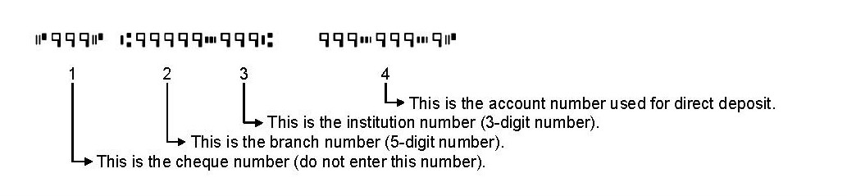

Please send updated information to Payroll Services, Department of Human Resources & Employee Relations, Suite A, East Office Building, prior to payroll deadline to ensure transactions are processed for the pertaining pay period. Thank you.



